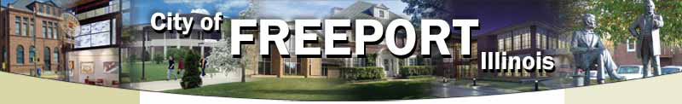Save the Date:

50th Annual Salter-Saulter Family Reunion

July 5, 6, 7 2019
The Historical Home of The Salter/Saulter Family Reunion
“Back to the Beginning”
The 50th Annual Salter/Saulter Family Reunion Committee
Welcomes You to Freeport, Illinois
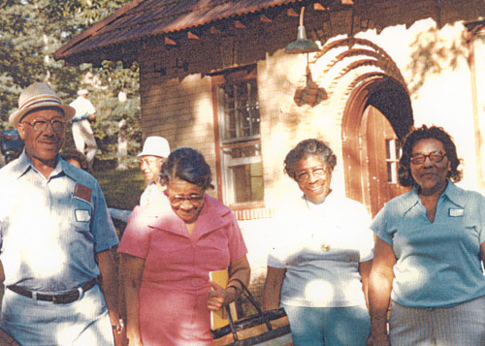

Paul, Angie, Josephine, Edna and Lonnie

“Do Not Miss This Special Reunion – Please Honor This History”

Hotel Information

Country Inns & Suites by Carlson

1710 Dirck Drive - Freeport
Phone – 815-233-3300 or 1-800-456-4000

7 Double Queens - $105.00 + tax
3 Single Kings - $105.00 + tax

Cutoff Date: June 5^{th.} 2019 Deposit required by credit card

Hampton Inn – Freeport

109 S. Galena Ave. Freeport, IL 61032
Phone – 815-232-7100 or Fax 815-232-7144

2-10 Queen Beds - $109.00 + tax
1-5 King Beds - $109.00 + tax

Cutoff Date: June 5^{th.} 2019 Deposit required by credit card

Baymont Inn & Suites- Freeport

1060 Riverside Dr. Freeport, IL 61032
Phone – 815-599-8510 or Fax 815-599-8610

Double (2 Beds) Limit 5 to room (1 Person $80.00) (2 Persons $80,00) (3 Person $86.00)
(4 Person $92.00)
King (1Bed) Limit 3 to room (1 Person $80.00) (2 Person $80.00) (3 Person $86.00)
Cutoff Date: June 5, 2019 (Deposit required by credit card or cash $60.00 per room)

Super 8 of Freeport

1551 S. Sleezer Home Rd. (Phone 815-232-4455)
No rooms Reserved you can reserve a room.

Rates are for traditional two Queen Beds and one King Bed rooms (plus sales/occupancy tax). Check-in time: 3:00 pm; Check-out time: 12:00 pm. These rates are available from Thursday, July 5 through Sunday, July 8 (Check-out at 12:00 pm).
To make reservations please call the Hotel prior to 12:00 am (midnight) CDT on June 5, 2019, and identify yourselves with the Salter-Saulter Family Reunion group.
Family Worship Service: 11:00 am
Saint Paul Missionary Baptist Church
607 E. Stephenson St Freeport, IL
When scheduling your trip - please plan to stay after church for food and fellowship. Plan to be delighted with a wonderful meal

“Do Not Miss This Special Reunion – Please Honor This History”

