Johnson Family Reunion Registration Form
August 8-11, 2024
Charleston, South Carolina

Name: ______________________ Email Address: _____________________

Join us at The Mills House, Charleston’s iconic Pink Hotel

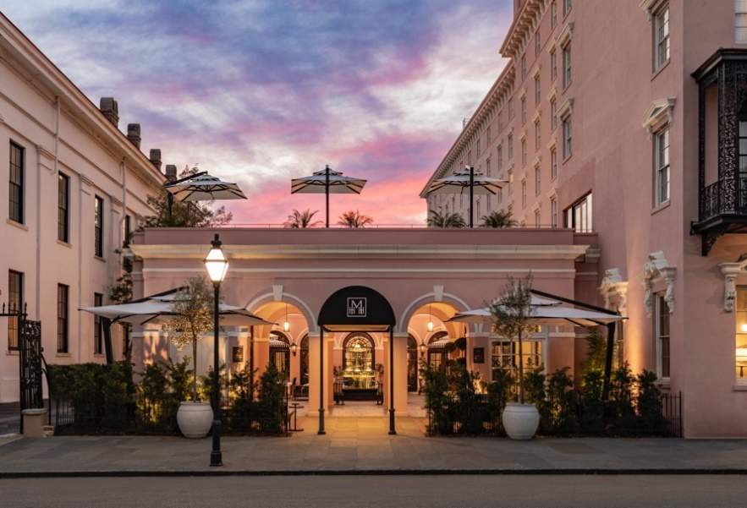

The Mills House Room Reservation Information

Here is your booking link: www.hilton.com/en/attend-my-event/johnson-family-reunion/
If guests prefer to call and book over the phone, they can call 843-577-2400 and refer to the group room block as Johnson Family Reunion. Room Rates are $249.00 per night.

Event Information

Thursday, August 8

5:00 PM - Meet up with family on the Meeting Street Terrace
This open-air terrace, located on the hotel’s second floor, overlooks iconic Meeting Street

Friday, August 9

Breakfast at leisure at Iron Rose, where you can dine in the hotel’s historic courtyard, elegantly designed bar to expansive dining room. The restaurant opens at 7:30 a.m.

1:00 PM - Family Group Tour of International African American Museum
Address: 14 Wharfside St, Charleston, SC
The International African American Museum is a museum of African American history on the site where Gadsden's Wharf, the disembarkation point of up to 40% of all American enslaved persons, once stood.

Get your order as soon as possible, as we have space for:
- 20 Group Adults: Cost $20.00
- 16 Group Seniors (62+): Cost $12.00
- 10 Group Youths: Cost: $9.00
- 6 and under free however counted in group size

3:00 PM - Family Gathering Meet and Greet at Hampton Park
Cost: $10.00
Address: 30 Mary Murray Dr, Charleston
(843) 724-7321

Saturday, August 10

Breakfast at Leisure at Iron Rose or The Black Door Café
Brunch begins at 8:00 a.m. at signature restaurant Iron Rose on Saturday and Sunday. If you prefer pastries, breakfast sandwiches and delicious coffee, visit The Mills House’s vibrant all- day café, The Black Door Café, which opens at 6:30 a.m. daily.

Saturday, August 10

Two Hour Charleston Black History, Gullah Geechee & Porgy & Bess Tour by Sites and Insights Tours
Cost is $25 per adult and $20 per child (12 and under). Each time slot can accommodate up to 25 people.
Option 1: 10:00 AM
Option 2: 12:00 Noon
The tour is conducted on board a 25-passenger bus. Our tour guide is a veteran licensed tour guide, author, and lecturer, Al Miller, aboard a plush air-conditioned tour bus. The tour covers most of downtown Charleston's Historic District\will including Site of the Hanging Tree, Grove Plantation House and much more.

Afternoon at Leisure

Explore downtown Charleston/ Shopping on King Street /The Beach/ Day Cruises/ Horse-Drawn Carriage Rides, where you can take a ride through the city’s cobblestone streets. / The top beach is Isle of Palms, about 15 minutes from downtown Charleston.
**See hotel concierge for information and bookings

Another great attraction, The City Market is a historic market complex in downtown Charleston. The market stretches for four city blocks through a continuous series of one-story market sheds. Open until 10:30 p.m. on Friday and Saturday

Saturday, August 10
6:00 – 11:00 PM – Denim and Diamond Family Event – Walk the Red Carpet! 6pm
Located in Planters Suite, on the second floor of The Mills House

"Denim and Diamonds" means casual and formal wear worn together in a glitzy/bling way, Jeans and rhinestone jewelry. Dresses with cowboy boots and bling accessories, pantsuits made with sequined or rhinestone fabrics and paired with denim jackets.

Prizes for best family coordinated look and more.
Heavy Hors d’oeuvres –Wine and Soft Drink Bar – Cost $25

Sunday, August 11
Breakfast at Leisure at Iron Rose or The Black Door Café
Brunch begins at 8:00 a.m. at signature restaurant Iron Rose on Saturday and Sunday. If you prefer pastries, breakfast sandwiches and delicious coffee, visit The Mills House’s vibrant all- day café, The Black Door Café, which opens at 6:30 a.m. daily.

9:30 AM – Depart for Service at Mother Emanual Church
Emmanuel African Methodist Episcopal Church (Mother Emanuel Church)
110 Calhoun Street, Charleston, SC

Note: Gospel Brunch will be at 12 PM if you choose to attend

------------------------------------------------------------------------------------------------------------

Name: _____________________ Email Address: _____________________

Please specify Events and total number attending:

- International African American Museum. (See cost by age - above) __________________
- Family Gathering Meet and Greet - Cost $10.00- 12 and under free ___________
- Black History, Gullah Geechee & Porgy & Bess Tour - Cost $25.00 _____________ Time
- Denim and Diamonds Gala: Cost Person -12 and under _________________
- Summary: Total Costs Due from events above $ __________________________

Number of People 12 & over __________ Number of children 12 & under _______
Names of additional attendees:

____________________________________ __________________________________

____________________________________ __________________________________
Send electronic payments to: Kim Johnson via Zelle or PayPal @KLJOHNSON730@gmail.com or
Send checks to: Joyce Boggess 1912 Atwood Ave. # 105 Madison, WI 53704

Please send Registration Form and payment by 5/16/24 no later than 6/5/24) to Kim Johnson at email listed above or Email Joyce Salter Johnson email address joyceboggess39@gmail.com

